Date of Issuance: January 2020
Version: 4.0

FinTechSpace
Application Guideline
(For International Startups)

Hosted by: Taiwan Financial Services Roundtable (TFSR)
Executed by: Institute for Information Industry (III)

January 2020

Table of Contents

I. BACKGROUND 3
II. OBJECTIVES 3
III. RESIDING RESOURCES 4
IV. RECRUITMENT TARGETS 6
V. RESIDING PLANS 6
VI. REVIEW PROCESS 10
VII. RESIDENTS’ RIGHTS, DUTIES and BENEFITS 13
VIII. OTHER NOTIFICATION 15

List of Tables
Table 1 FinTechSpace Residing Resources 4
Table 2 Application Conditions 6
Table 3 “Private Office” Offers 7
Table 4 “Fixed Seat” Offers 8
Table 5 “Hot Desk” Offers 9
Table 6 Overview of the Application Notification 12

List of Figures

Figure 1 FinTechSpace Recruitment Process 11

- BACKGROUND
The period of execution for the “Financial Technology (Fintech) Innovation and Startups Talent Cultivation Plan” certainly proved it as a worthy prototype for the Taiwanese fintech industrial environment to follow. Aiming to perpetuate and enhance this Plan’s overall contributions, accelerating the construction of pillars for the national fintech industry, and consolidating its push for innovation, the Financial Supervisory Commission (hereinafter referred to as FSC) has, on May 10th of 2017, delivered instructions to the Taiwan Financial Services Roundtable (TFSR) as to establish the FinTechSpace. Thus, the TFSR has commissioned the Institute for Information Industry (III) to organize and, in 2018, start the FinTechSpace officially.

OBJECTIVES
FinTechSpace is the first fintech-focused coworking space in Taiwan. There are three main objectives:
(1) Effectively integrating resources across industrial sectors, so as to virtually establish a space for fintech innovation;
(2) to build a startup network that can serve as a strategic gateway for Taiwan’s fintech industry towards the international scene;
(3) to provide supervision and diagnosis of financial regulations and, through the FSC’s fintech development and innovation experimental regulations, to accelerate the development of fintech innovation and startups within the country.
To achieve the aforesaid objectives, FinTechSpace intends to recruit domestic and international fintech parties residing in the space. Targets include fintech startup, technology startups, technology companies, financial organizations, academy organizations, etc. The following information will describe the procedure for the recruitment, resources, and obligations.

RESOURCES
Considering each company’s individual stage of development, FinTechSpace offers 3 residing plans: “Private Offices”, “Fixed Seat”, and “Hot Desk” for application. Regarding to each plans, FinTechSpace offers different incubating resources as following:
Table 1 FinTechSpace Residing Resources
PLANS  ITEMS |  | PROVATE OFFICE | FIXED SEAT | HOT DESKS
Spaces Resources
Period Per Batch |  | 12 months | 12 months | 6 months
Company Address Registration |  | V | V | -
Meeting Room |  | V | V | ◎
LIVE-Stream Room |  | V | V | -
Live House (100+ people event) |  | △  1 free section per 6 months |  | △  Charged for using
Phone Booth |  | V | V | V
Memdatoring Room |  | V | V | -
Common Space |  | V | V | V
FinTech Entrepreneurship Resources
Domestic | Talks & Ask  - Entrepreneurship Talks  - Regulation Check  - Information Security Clinics  - Financial Regulation Talks  - Technology Ask | V | V | V
 | Coaching  - 1-on-1 Mentoring  - Market Mentoring & Consulting  - GISA Application Assistance | V | V | ◎
 | Matchmaking and Pitch  - In-house Matchmaking Meetings  - Showcases | V | V | V
International | International Market Coaching | V | V | -
 | International Exchange Programme | V | V | -
Technology | Cloud-Platform Resources. | V | V | △  Depends on the agreements with individual partners
Regulation | Regulatory Clinic | V | V | V
Others
Mentoring for Application of Digital Sandboxes |  | V | V | V
Note:
1) ◎ means Private Office and Fixed Seat have priority to access, with the rule of “first-using applicants first”。
2) GISA means the “Go Incubation Board for Startup and Acceleration Firms”. Established by TPEx in January 2014, GISA is designed as the platform for small-sized non-public innovative companies with creative ideas, and to offer entrepreneurship counseling and capital raising functions, but not trading functions to help innovative companies to acquire needed capital.
Sources: FinTechSpace

RECRUITMENT TARGETS
The ideal targets for FintechSpace residing Startups are focused on fintech or technology startup companies with foresight and high potential on Fintech industry. The conditions for the applicants are as follows:
Table 2 Application Conditions
PLANS  CONDITIONS | PRIVATE OFFICE | FIXED SEAT | HOT DESKS
Industry | Products or services MUST related to “Financial Technology”.
Product Requirement | There is already a prototype for a product related to fintech (prototype) or the product has been launched for less than three years.
Company Age | Companies legally registered in Taiwan  (This limitation doesn’t apply for international teams)
Size of the Company/Startup | - At least 4 and no more than 20 staff members. | －
Sources: FinTechSpace

RESIDING PLANS
Considering each company’s individual stage of development, FinTechSpace offers “Private Offices”, “Fixed Seat”, and “Hot Desk” for application. Limited by the place FinTechSpace has at this stage, adjustment of actual existent spaces might need to be considered after review of all applications. More details of individual residing offers are as follows:

Table 3 “Private Office” Offers
ITEMS | PRIVATE OFFICE
Rent | - Before & After Rental Subsidies：( Unit: NTD)  PLANS FEE&SUBSIDY Small Office (4 ppl) Medium Office (8 ppl)  Fixed Price 20,000 40,000  30% OFF(/room) 14,000 28,000  - Payment method:  - The Residing Rental Fee of one office is paid in Monthly, and should be done before the first day of each month, and reply the information with email.
Residing Duration | - One period of accommodation consists in 12 months, and each company can only apply for one period at a time.  - If, after residing, a company needs to lodge out before the period established by the contract is ended, FinTechSpace should be informed with at least 2 months of anticipation. None of the rental fees nor the deposit paid can be refunded.
Application Limits | - Based on its actual needs, a single company is limited to apply for 2 private offices at a time.
Equipments | - Wifi of whole area; wired Ethernet connection is also provided inside of the office.  - Office desks, chairs and other related office facilities are included.  - Telephone line is needed to be applied by residents.
Others | - A deposit (the Fixed Rental Fee for one month) should be paid in the 1st month of rent.  - The deposit must be paid by cheque at sight, and refund after moving out.  - Utility bills are included. However, if it is used without permission during the non-opening hours, or the wires and pipelines are damaged due to improper use, FinTechSpace reserves the right to request payments.  - The address of FinTechSpace is available for Private Office and Fixed Seat residents to self-register as company’s registered address. Residents must complete the shift-out process before moving out.  - The deposit will be refunded once the residing company is verified no leaving damage to the FinTechSpace, and to complete the shift-out process of Company address registration.
Note: FinTechSpace reserves the right to ask each company for individual compensation caused by without any permission or inappropriate usage.
Sources: FinTechSpace
Table 4 “Fixed Seat” Offers
ITEMS | FIXED SEAT
Rent | - Before & After Rental Subsidies：( Unit: NTD)  PLANS FEE&SUBSIDY FIXED SEAT  Fixed Rental Fee/month 4,000  30% OFF(/seat) 2,800  - Payment method:  - The Residing Rental Fee of one office is paid in Monthly, and should be done before the first day of each month, and reply the information with email.
Residing Duration | - One period of accommodation consists in 12 months, and each company can only apply for one period at a time.  - If, after residing, a company needs to lodge out before the period established by the contract is ended, FinTechSpace should be informed with at least 2 months of anticipation. None of the rental fees nor the deposit paid can be refunded.
Application Limits | - Based on its actual needs, applicants are limited to core members of the company.
Equipments | - Wifi of whole area  - Office desk, chair and other related office facilities are included.
Others | - A deposit (the Fixed Rental Fee for one month) should be paid in the 1st month of rent.  - The deposit must be paid by cheque at sight, and refund after moving out.  - Utility bills are included. However, if it is used without permission during the non-opening hours, or the wires and pipelines are damaged due to improper use, FinTechSpace reserves the right to request payments.  - The address of FinTechSpace is available for Private Office and Fixed Seat residents to self-register as company’s registered address. Residents must complete the shift-out process before moving out.  - The deposit will be refunded once the residing company is verified no leaving damage to the FinTechSpace, and to complete the shift-out process of Company address registration.
Note: FinTechSpace reserves the right to ask each company for individual compensation caused by without any permission or inappropriate usage.
Sources: FinTechSpace
Table 5 “Hot Desk” Offers
AUG
SEP
7月底
審議
委員會
8月初
審議結果通知
8月
契約簽訂
9月
園區進駐
ITEMS | HOT DESK
Rent | - Before & After Rental Subsidies：( Unit: NTD)  PLANS FEE&SUBSIDY HOT DESK  Fixed Rental Fee /month 3,000  /duration (6 months) 18,000  30% OFF(/seat) 30% OFF(/seat) 2,100  /duration (6 months) 12,600  - Payment method:  - The Residing Rental Fee is paid in ONE time, and should be done before the first day of the residing month. Residents shall reply the information with email.
Residing Duration | - One period of accommodation consists in 6 months. Each company can only apply for one period at a time, yet, can apply for an extension (6 months) depends on individual need.  - If, after residing, a company needs to lodge out before the period established by the contract is ended, FinTechSpace should be informed with at least 2 months of anticipation. None of the rental fees nor the deposit paid can be refunded.
Application Limits | Based on its actual needs, applicants are limited to core members of the company.
Equipments | - Wifi of whole area.
Others | - A deposit (the Fixed Rental Fee for one month) should be paid in the 1st month of rent.  - The deposit must be paid by cheque at sight, and refund after moving out.  - Utility bills are included. However, if it is used without permission during the non-opening hours, or the wires and pipelines are damaged due to improper use, FinTechSpace reserves the right to request payments.  - It is also open for temporary registration, however, there is no guarantee for temporary registers tables and chairs in the FinTechSpace.  - The deposit will be refunded once the residing company is verified no leaving damage to the FinTechSpace.
Note: FinTechSpace reserves the right to ask each company for individual compensation caused by without any permission or inappropriate usage.
Sources: FinTechSpace

REVIEW PROCESS
AUG
SEP
7月底
審議
委員會
8月初
審議結果通知
8月
契約簽訂
9月
園區進駐
The applying companies need to pass the review meetings and abide by the regulations established by FinTechSpace. The review process can be divided into two stages: First stage: Eligibility Review; Second stage: FinTechSpace Review Committee meetings. The FinTechSpace application review committee will perform the rightful evaluation of whether each company matches the conditions for accommodation and to obtain the subsidies, including each startup’s actual level of development.

- Review Standards
- Applicants characteristics (completeness, complementariness, creatives)
- Feasibility of the company’s market operations
- Innovation of the company’s technology, products or commercial operations
- Wholeness of the company’s products and/or services
- Competitive advantages of the company’s products and/or services
- Applicants’ skills of implementation
- Potentiality for International Expansion
- Invested value

- FinTechSpace Recruitment Process

Apr. 1st
Contract Signing
Join into the FinTechSpace
1st Screen
(Eligibility Review)
2nd Screen
(Pitching)
Open for Application
Mar. 17th -31st
Batch List released
Confirmation Applicantss
Mar. 9th
Application Deadline
Feb. 27th
Mar. 3rd
Mar. 13th
Mar. 17th

Sources: FinTechSpace
Figure 1 FinTechSpace Recruitment Process

Table 6 Overview of the Application Notification
Items | Application Notification
Review Process | - Online submission  - Document review  - Review meeting
Application period | - The Recruitment schedule shall be announced on the FinTechSpace’s official website.  - The third recruitment period shall start on January 22nd, and applications will be received until February 27th.
Qualification | - Established company only.
Application Method | Email the necessary documents to FinTechSpace’s official electronic mailbox (fintechspace@iii.org.tw). Please enter the subject for the e-mail as:  - “FinTechSpace Application: OOOO(name of the company)”
Necessary documents | - Application Form (Attachment 1)  - Business Plan (Attachment 2)  - Recommendation letter(s) (Attachment 3, non-mandatory application document; if provided, the letter must carry a seal from the issuing organization)
Sources: FinTechSpace

RIGHTS, DUTIES and BENEFITS
What these rules refer to as “FinTechSpace Residing Startup/Companies” are fintech startup companies who have signed the Residing Agreement with III. Accommodating into Private Offices or a Fixed Seats Startups/Companies are also called as “Incubating Startups”. All FinTechSpace Residing Startup/Companies must agree to the following rights, duties, and to the following items regarding benefits:
- Rights
- During the accommodation period:
Residing Startup/Companies which reside in 2020 are granted to reside Private Office or Fixed Seat for 12 months (from 1st April 2020 to 31st March 2021) or to reside Hot Desk for 6 months.
- Residing Startup/Companies can apply for corresponding mentoring resources provided by the FinTechSpace.
- Duties
- The Residing Startup/Company needs to agree with the rules stated herein and with the “FinTechSpace Accommodation Management Regulations”
- To make the Space’s use of resources as efficient as possible, the Residing Startup/Company must agree and abide to the stated use since the time of application, including the Space’s stipulated rate of resource usage, and performance assessments and scale assessments of the accommodated companies.
- It is necessary to inform FinTechSpace, if the business model is adjusted due to the company's development after entering.
- In order to make the FinTechSpace's resources more efficient, the resident company must agree and comply with the use when applying, including the use of FinTechSpace's resources, the effectiveness evaluation of the resident company, and the size evaluation.
- After the contract is signed, and upon the first payment of the rental fee, an additional fee equal to one month of the rental fee must also be paid as the deposit fee. The deposit fee shall be refunded to the company when lodging out has been finished.
- If, during the accommodation period, issues related to operations or services arise and lodging out is necessary, the company shall lodge out according to the process stipulated by the contract, receiving help from the Space.
- The payment of the rental fee for the location/facilities must be executed punctually, along with expenses for water, electricity, maintenance, etc., during irregular working hours.
- If, for any circumstance, the accommodated company needs to lodge out before the contract’s stipulated time arrives, the Space’s management center should be informed at least 2 months prior to lodging-out. If the company fails to inform FinTechSapce pursuant to the aforementioned period, the deposit fee will not be refunded.
- The Residing Agreement must be signed within 15 days after the announcement of the residing list.

- Benefits
    - Development Follow-up: the residing company agrees to provide relevant information, e.g. the company’s operational experience, operation performance, and fundraising circumstances.
    - Promoting: the residing company agrees to provide texts, videos, images, photographs or any physical activity, with the purpose to advance the entire development of the fintech industry.
    - The company agrees to provide the aforementioned information voluntarily, without any fee, to FinTechSpace for its use on showcases, exhibitions, advertisements, sharing sessions and other activities.

OTHER NOTIFICATION
- If, during the execution of the FinTechSpace, any of the companies supported by the FinTechSpace infringes upon other company’s operational privacy, intellectual property rights or any other similar right, and thus incurs into a legal dispute, the selected company is solely responsible for all legal consequences.
- Any outcomes arrived at by the accommodated company’s research efforts belong solely to it. This excludes situations where the Law or Subsidy Agreements stipulate otherwise.
- Except for information that needs to be kept confidential or disclosed on a restricted basis under Article 18 of the Freedom of Government Information Law, the guide offered by these application rules, such as the selection date, amount of subsidies and all other related information will be published on the FinTechSpace’s official website (http://fintechspase.com.tw).
- If a selected company falls within any of the following circumstances, the review committee can make the decision to finish the contract before the stipulated deadline and require the said company to lodge out:
  - The real details about the company do not match those provided during application
  - Investigation reveals that members of the selected company have incurred into illegal acts.
  - The fees agreed to by both parties aren’t paid on time.
  - Any of the terms and conditions stated by the application rules or the contract signed by both parties are infringed upon.
  - Progress reports fall behind by an extreme margin.
  - Other severe occurrences.

- Contact information
Institute for Information Industry
Telephone Number:
- (02)6607-2751 Ms. Vicky Chu
Email: fintechspace@iii.org.tw
Official Website: http://fintechspace.com.tw
Address: 13F, No 1, NanHai Rd., ZhongZheng District, Taipei City

Date of Issuance: January 2020
附件一

Attachment 1. “FinTechSpace Application Form”

I. Application Form
* The following content must be filled out
A. Profile:
Company Name |  | Representative of the Company
Amount of Core Members |  | Amount of All Staff Members:
Capital |  | Operating Revenue from Last Year
Core Technology
Product/Service Name
Address
Contact Person |  | Telephone Number | （ ）
Mobile |  | email
B. Documents check (for applicants who haven’t registered companies in Taiwan)
- Application form (Attachment 1)
- Business Plan (Attachment 2)
- Recommendation letter(s) (Attachment 3, optional to provide; if it is provided, a seal from the issuing organization on the letter is necessary)
C. Application Options:
- Hot Desk: ________seat(s), 6 months
- Fixed Seat: __________seat(s), 12 months
- Private Office:
  - Small size ( 4 people) ________office(s), 12 months
  - Medium size ( 8 people) _________ office(s), 12 months

Please submit the all application documents through email (fintechspace@iii.org.tw).
If there are any attached documents, an official stamp by the issuing company and noted with the words “same as the original document” are necessarily.
The applicant guarantees that the information provided above totally complies with reality, and responsible for legal consequences.

Representative Signature :

Applicant Company Seal:
簽

Date: / /2020

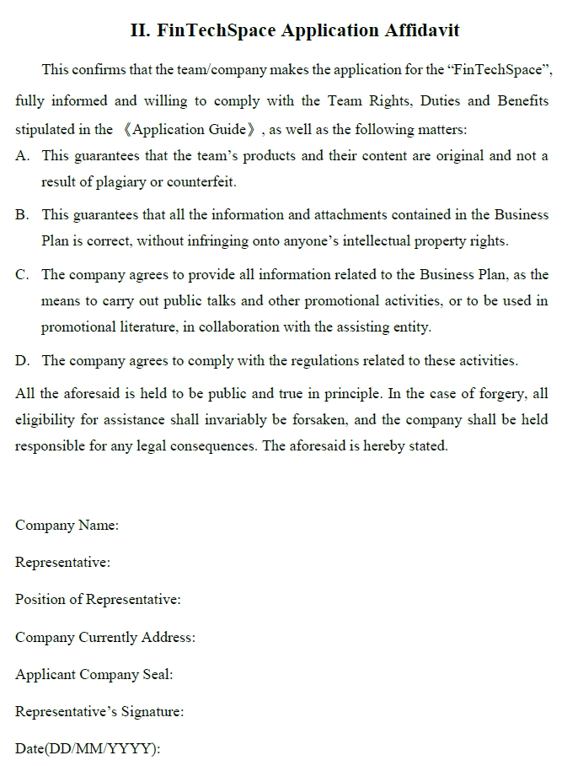
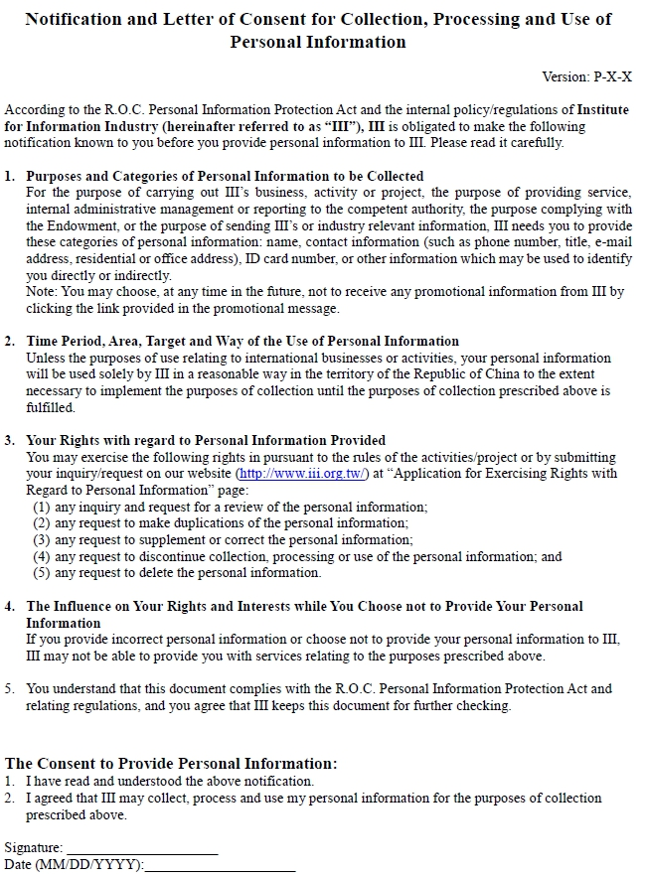
Version: P-v4-DSI
附件二

Attachment 2.”Business Plan”

Applicant company:
Applicant (representative person):

DATE: 2020_______(MM)_______(DD)

Abstract

- Guidelines

- Applicant’s Information

- Abstract of Business Plan

- Business Plan
  - COMPANY GOALS & OBJECTIVES
  - BUSINESS PLAN
  - EXECUTION PLAN
  - DEVELOP PROCEDURE
  - CORE TEAM
  - CAPITAL ALLOCATION
  - PROFIT MODEL
  - RISK ASSESSMENT
  - PERSPEVTIVE

Appendix. Capital Allocation Form

Guidelines

- Please use A4 size paper with horizontal writing (from left to right) with page numbers at the bottom
- If table length or fields are insufficient, please make your own adjustments.
- Please draft the Plan in the form of “Development Plan”. If certain items need to be left blank, please fill in with “None” (please don’t leave it blank). If there is other information you would like to add, please feel free to add it based on your own needs.
- All information from public market surveys should clearly specify its sources and dates.
- Make sure all information is consistent, based on fact.
- The unit used for all amounts of money should be NTD$, rounded to the nearest integer.
- Please state concisely the total number of pages of the Plan; the limit is 30 pages.

- Applicant’s Information

- Application Summary：
Company name
Person Responsible for the Company: | Full Name
 | Contact Phone Number | ( ) | Mobile Phone Number
 | e-mail
Contact Person | Full Name
 | Contact Phone Number | ( ) | Mobile Phone Number
 | e-mail
Core Member | The amount of the core member is/are_____ people
Abstract  (within 200 words) | Company Goals and Objectives：
 | Service Model:
 | Expected Benefits:
 | Others:

- Company Information:
Name:
Address:
Telephone Number: | ( ) |  | Fax: | ( )
Responsible Person for the Company: | Full Name |  | Position
 | Contact Phone Number |  | Date of Birth (DD/MM/YYYY)
Company Website
Capital
Operating Revenue
Date of Establishment (Registration)
Amount of Staff Members
Company Profile
(within 200 words)
Awards

- Expected personnel: (please increase the field according to individual application requirements)
No. | Name | Title
1
2

- Abstract of Business Plan

（Please make sure everything mention below has been described in the follow business plan）

Points of Major Product/Services  創業主要商品/服務項目 |  | Pages
1 | Innovation ideas (創新構想) | (e.g. p.15)
2 | Links and Benefits  (鏈結與效益)
3 | Technical differences and technical capabilities  (技術差異性及技術能力)
4 | Market Opportunities Development Capacity  (市場商機發展力)  (compare the status of competition , business opportunities and cross-border cooperation bonus or profit mode capability )  (現況競爭比較、商機及獲利模式或跨域合作加值潛力)
5 | The ability to connect to the international market  (國際市場連結能力)

- Business Plan
  - COMPANY GOALS & OBJECTIVES(計畫目標)
（future operation goals in 3-5 years）

  - BUSINESS PLAN (計畫內容)
- Main business description(主要業務說明)
(Please describe the mission statements, and your current business model)
- Innovation & Differentitaion (創新處)
(Please describe the advantage and innovative of your technology/service/product, and the problems expected to be solved.）
- Target Market/Market Size(目標市場與市場規模)
(Please describe the target market scale, trend, the type of customer characteristics, the expected barriers and entryway, and the growth potential of the market. How to compete the competitors in the market, and overcome incoming barriers are also necessarily to be mentioned.）
- Core Technology(技術或核心能力說明)
(e.g. license, patents, awards records, etc.）
- Competitiveness Analysis
(e.g. SWOT analysis, five forces analysis, competitor analysis, etc.）

  - EXECUTION PLAN(實施方法)
（Please indicate the business operations and revenue model）

  - DEVELOP PROCEDURE (執行進度)
（Please indicate the expected progress in the implementation of the process within 3 years）

  - CORE TEAM (團隊經歷/人力配置)
（Describe the core team line-up profile, patents, licenses, awards, work experience, entrepreneurial experience and work division. Advisory support shall be also mentioned in this section.）

  - CAPITAL ALLOCATION (資金運用)
(Please indicate the company's existing financial situation, including its own funds, loan amount, income source project, the next 18 months, and 3-5 years financial projections)

  - PROFIT MODEL (營運計畫)
(Please analysis developed by the company's business plans commercialize technologies or services, including product positioning, sales targets, market analysis, marketing plan, cost structure, revenue estimates and future fund-raising and investment planning, etc.)

  - RISK ASSESSMENT (風險評估)
(Please analysis potential difficulties or threatens happen in production, marketing, human resources, research and finance, and the corresponding plan.)

  - PERSPEVTIVE (預期效益)
(Please explain how to cooperate with financial institutions, and the expected benefits to taiwan finacial industry. Also, please estimated the annual output content in the next 18 months, including employees hiring , the number of patent applications , R&D results , estimated value, and the impact on the public arising etc. clearly.)

Appendix. Capital Allocation Form
(Abstracted from F. Capital Allocation)
Duration：the next 18 months
Unit:NTD
Milestone  (經費項目) | Expected cost  (金額) | Description  (說明)
Total Investment to FinTech  (總 計) |  | -

Attachment 3. Recommendation Letter
Recommending Organization:
Recommended Startup/Company:
Main Technology, Product(s) or Operational Model of the Recommended Team/Company:
Comments on Evaluation:
(A) The company’s technology, product(s) or operational mode are innovative or creative ideas:
(該公司之技術、產品或營運模式具備創新、創意概念)
(Please describe the recommended company’s technology, product(s) or operational mode’s innovative points and ideas)

(B) The company’s technology, product(s) or operational mode hold great potential for development:
該公司之技術、產品或營運模式具發展潛力
(Please describe the recommended company’s technology, product(s) or operational mode’s potential for development)

(C) The company’s technology, product(s) or operational model’s future plan and its duration are feasible:
該公司之技術、產品或營運模式未來發展之時程規劃具可行性
(Please describe the feasibility of the recommended company’s technology, product(s) or operational mode’s future plan)

(D) The company’s operation staff has the ability to implement the plan:
該公司之經營團隊具執行所提計畫之能力

(E) Others:
其他建議或補充說明事項

Recommending Organization : Seal
Date (DD/MM/YYYY):

Definition of FinTech: In accordance with the contents from the decrees of the “Regulations related to finances from information service and fintech industries as established by the competent authorities”, issued by the FSC on 2016 - Companies that use information or networking technologies to collect, manage, analyze and provide information as means to help in the development of financial organizations or industries. - Companies that use information or networking technologies to improve financing services or the security of certain functional processes. - Other companies who focus on information or technology, and design or develop digital financial services that are innovative.
The first period for accommodation spans from April of 2020 to March of 2021..
The first period for accommodation spans from April of 2020 to March of 2021.
For the documents that need to be prepared as an electronic file, please consult “FinTechSpace Application Rules”

